Tim Fang

2021-Nov-13

Foundations of Programming (Python)

Assignment 05

Continue Lists and Introduce Dictionaries

# Introduction

This document will describe what I learned from Module 05, outline the steps I took to complete the fifth assignment, and summarize some challenges. For this assignment, I will continue using Spyder to modify a CD inventory program. Similar to last week’s program, the user will have menu options, be able to enter new CD info and view the inventory, as well as save the entire inventory to a text file. New to the inventory program will be the ability to delete info. In the back end, the functionality of dictionaries will be incorporated. I will execute the program in both Spyder and Terminal.

# Midway Journey

Before I began this week’s assignment, I worked through Labs A & B. There were example solutions at the end of Module 05, but I worked as though they weren’t available. In truth, I didn’t read ahead or realize they were there. When I was satisfied with my results, I compared my scripts with the example solutions.

I realized my results needed more work to achieve the lab assignments. I grew frustrated and felt overloaded. Swimming in my mind was also how I completed last week’s assignment. I had used that program to help guide me through this week’s labs. Instead of tweaking just the sections where I needed more work, I decided to start over with each lab, learning why the solutions worked better. In all, I spent hours (again) testing the code, running into errors, and arguing with Python…

I was slightly annoyed to find a section on Script Templates on page 15 of Module 05. I would have found it more useful in Module 03 when we were introduced to working with Spyder. Admittedly, I lost points related to the header in Assignment 03, so that section could have been more helpful if presented earlier.

# Program Planning

I began this week’s assignment by reviewing the starter file, its pseudocode, and TODO items. Instead of filling in the rest of the code with our own script as with last week’s assignment, we were asked to change an existing program to incorporate dictionaries, add the ability to load data from file, and add the ability to delete data. The experience also meant I needed to weave my own script into someone else’s program. I tried to balance maintaining the original program and adding the requested changes with my own style.

Some menu options and their code didn’t need changes (ie. ‘exit’, ‘display’, or ‘save’). That allowed me to focus more time and attention on the requested additions. However, I still needed to validate and test the program from start to finish. The menu option I spent the most time with was ‘delete’ (read as hours of frustration and facepalming). What helped in the end was learning from other students’ work in GitHub and referring to Module 04, page 18. The function, *list.remove(x)*, is what I needed to modify in order to complete the assignment.

# Final Script

The following figures show the updated CD Inventory program as I cycled through each option.

Figure 1 shows the program’s initiation and a message if there’s no file to load from. The same option will load information after data has been saved to file.

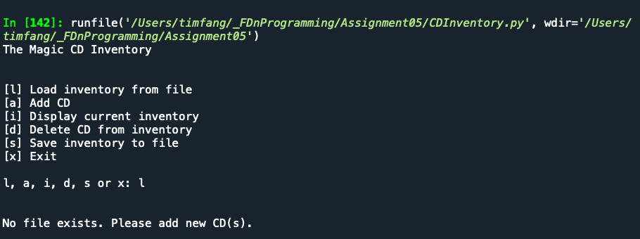

Figure - Magic CD Inventory, option 'L'

Figure 2 shows the program’s function when adding a CD and displaying the current inventory (in-memory).

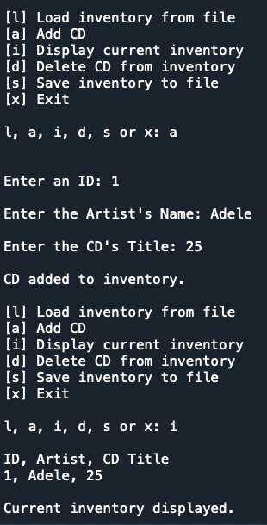

Figure - Magic CD Inventory, options 'A' and 'I'

Figure 3 shows the program’s function when saving the current inventory to file and what happens when the file content is loaded back to in-memory.

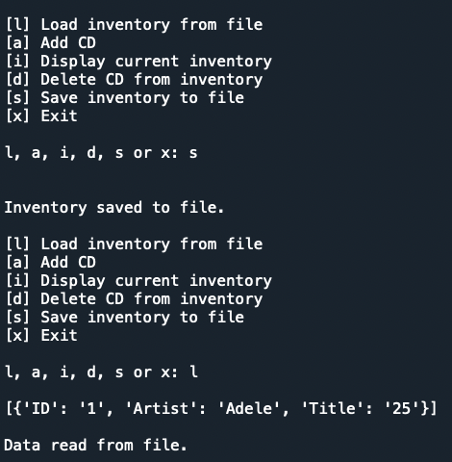

Figure - Magic CD Inventory, options 'S' and 'L'

Figure 4 shows the text document’s content after the inventory is saved to file.

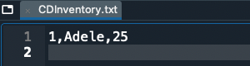

Figure - Magic CD Inventory, txt file contents

Figure 5 shows the program’s function when deleting a CD and confirms an empty inventory after deletion.

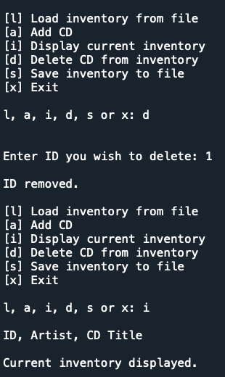

Figure 5 - Magic CD Inventory, options 'D' and 'I'

Finally, Figures 6 & 7 show the program functioning in Terminal. For brevity, the screen shots show the main options of the program.

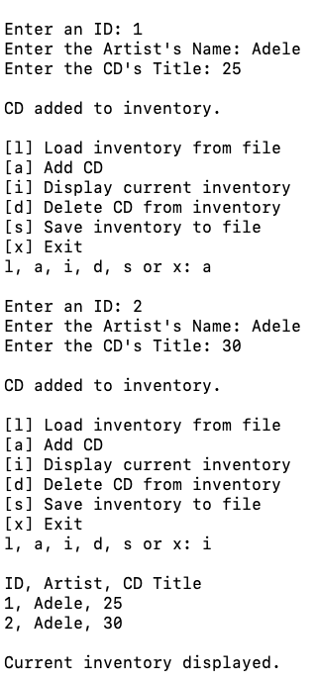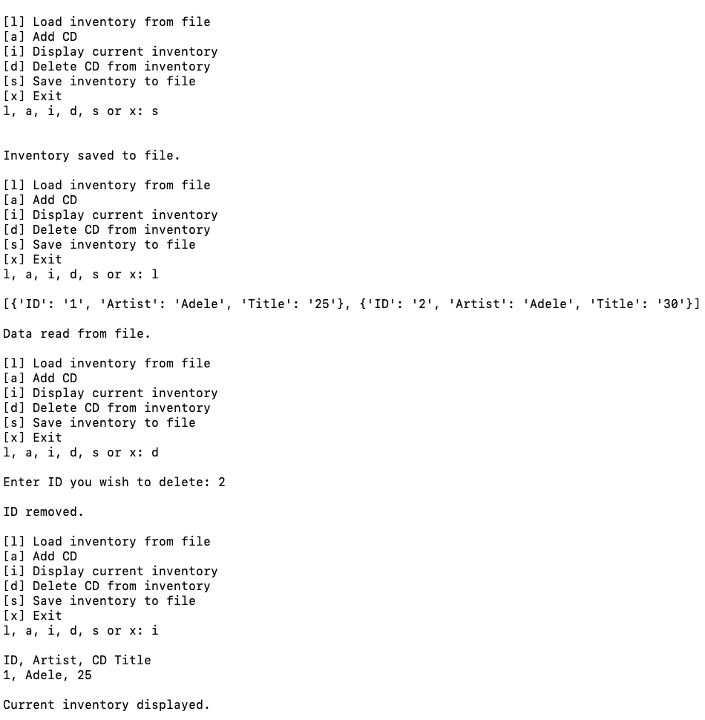

Figure 6 & 7 - Magic CD Inventory in Terminal, options 'A' and 'I', then ‘S’, ‘L’, ‘D’, and ‘I’ again to confirm deletion

# Summary

Several times thus far, I’m reminded of general science courses during the first couple of years in undergrad. The challenges weren’t the complexity of the subject matter but the volume of new information and trying to make connections. I expected there would be work going into this course. I didn’t expect to spend my waking hours from Fri – Sun just working through each week’s material.

# Appendix

As requested, I’ve included a link to my repository on GitHub for this assignment.

<https://github.com/timsfang/Assignment_05>